

ASSIGNMENT 05

SUBMITTED TO: MR. MUBASHIR IQBAL
SUBMITTED BY: AHMED SALEEM RANA
REG ID: 24-CYS-023
SECTION: B

HITEC UNIVERSITY TAXILA, CANTT

TASK 01

Write a Python program to find the maximum and minimum value of a given flattened array. Expected Output:
• Original flattened array:
[ [0 1], [2 3] ]
• Maximum value of the above flattened array: 3
• Minimum value of the above flattened array: 0
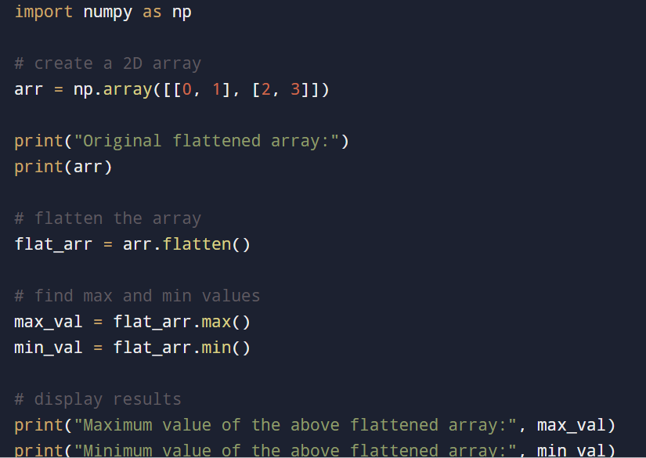
INPUT:
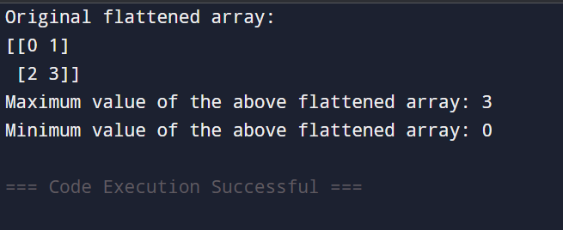
OUTPUT:
TASK 02

Create a 3x3 matrix with values ranging from 2 to 10.
INPUT:

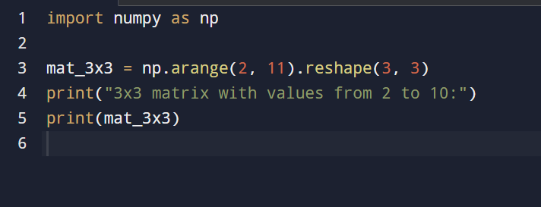

OUTPUT:
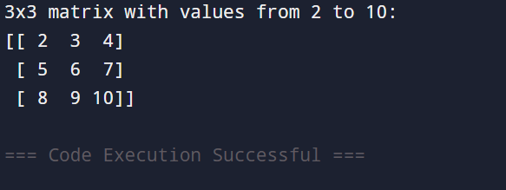

TASK 03

Write a NumPy program to convert an array to a float type. Sample output:
• Original array [1, 2, 3, 4]
• Array converted to a float type: [ 1. 2. 3. 4.]

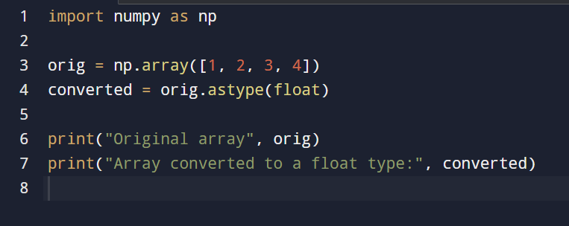
INPUT:

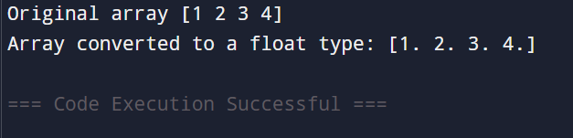
OUTPUT:

TASK 04
Multiply 2 x 2 matrix and take transpose of a resultant matrix.
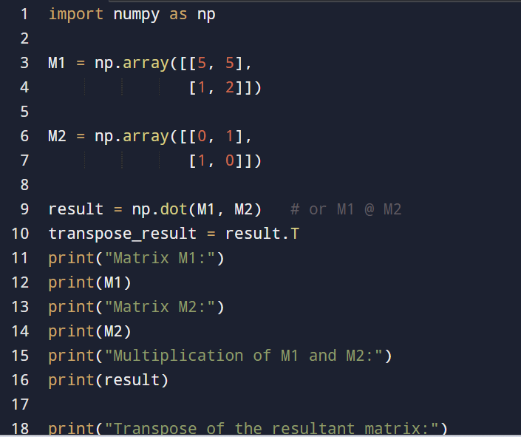
INPUT:
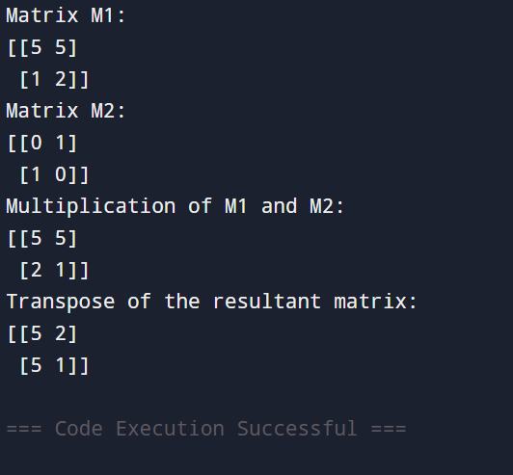
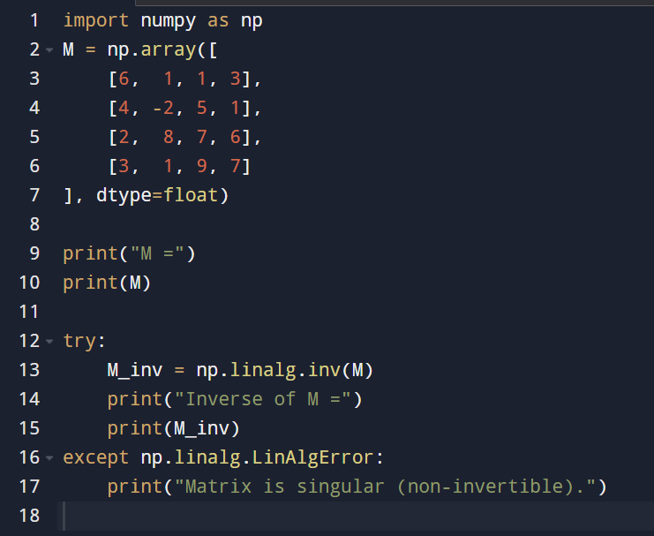
OUTPUT:

TASK 05

Find inverse of matrix.
INPUT:
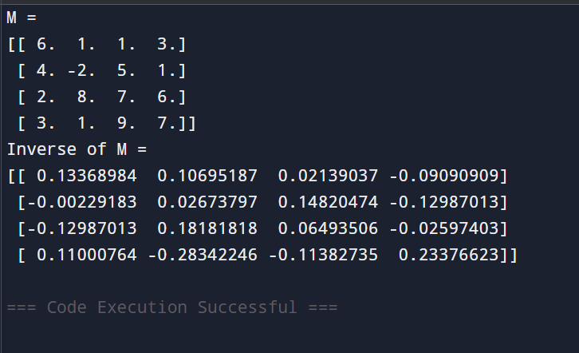
OUTPUT:

CONCLUSION:
In this lab, we efficiently used NumPy to perform a variety of numerical and matrix-based operations. We explored how to flatten arrays, find maximum and minimum values, create matrices with specific ranges, convert data types, and perform matrix multiplication and transposition. Additionally, we calculated the inverse of a matrix using NumPy’s linear algebra functions. These tasks demonstrate how NumPy simplifies complex mathematical operations and provides fast, reliable tools for data handling and computation. Overall, this lab enhanced our understanding of matrix operations and showed the importance of NumPy in scientific and engineering applications.

